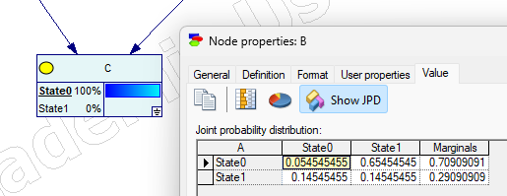

**Zadanie 10**

Bramki noisy – or

Wykorzystując bramki NOISY – OR zmodyfikować model A Car Start Problem.

P(s|d)

P(n|d)

P(s|d,w)

P(n|d,w)

